Tutorial 4.3

*Stan Wan*

**Step 1&2: Import and rate constants (line 1 - 71)**

I imported PR_dend_gating, PR_soma_gating from pm_functions.py. And 6 outputs generated by each function are plotted by a vector of the membrane potential (between -0.085V and 0.050V) and a vector of calcium concentration (between 0 and 2 × 10^-3M)

Above are rate constants for Dendrite gating, below are rate constants for Soma gating.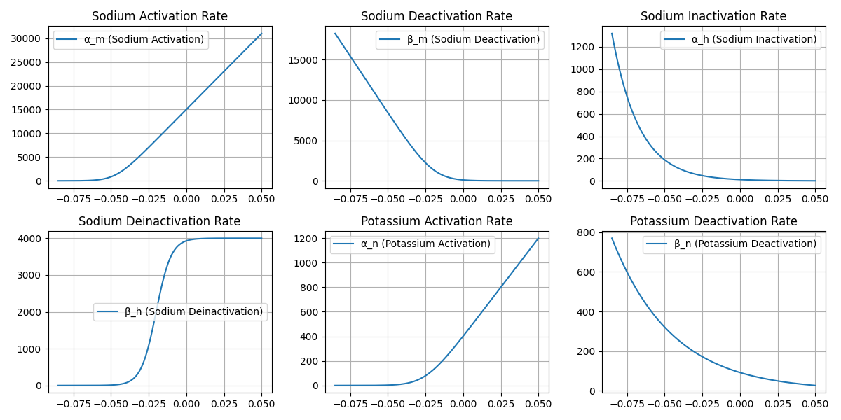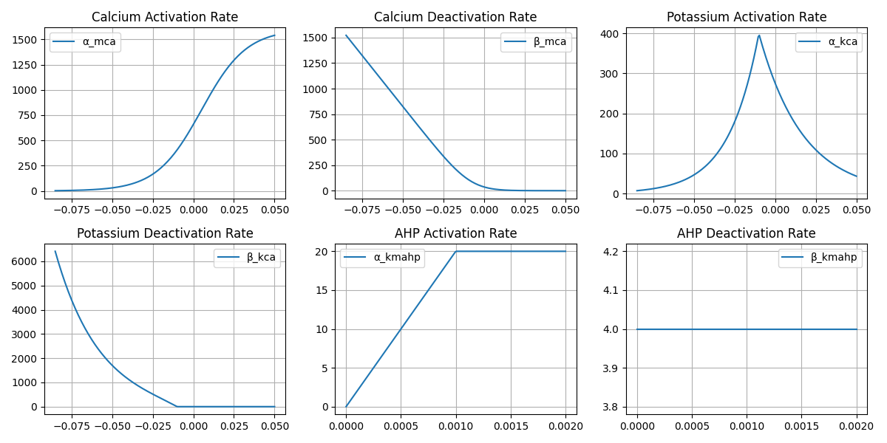

**Step 3&4: Simulating the PR Model and Detect Somatic Spikes (line 74 -209)**

This simulation models the Pinsky-Rinzel two-compartment neuron, where:

* Dendritic compartment generates calcium spikes.
* Somatic compartment generates action potentials.

The simulation runs for 2 seconds with a 2 μs timestep and solves the differential equations governing ion channel gating and membrane potential dynamics.

The functions and parameters implemented were the same from figure 4.16, except the k-value = 5e6 and G_Link = 50nS.

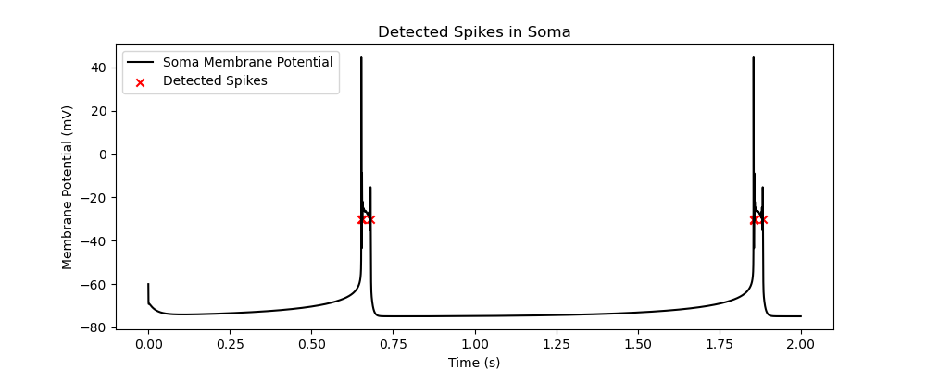

There were more spikes than my previous submission said, but I did not find any error in parameters used. So I fixed the threshold that counts as a spike and above is how the plot looks.

In the 2s time period, two bursts (almost exactly with a 1s interval between) are generated and the **number of spikes** returned by my code is **8**, which means each cluster consists of 4 single spikes.

**Step 5: Assess Model Behavior with Different G_Link Values (line 212 - 226)**

Runned the simulation for different coupling conductances (G_Link = 0 nS, 10 nS, 100 nS) and observed how Soma potential changes.

**Timing of Bursts:**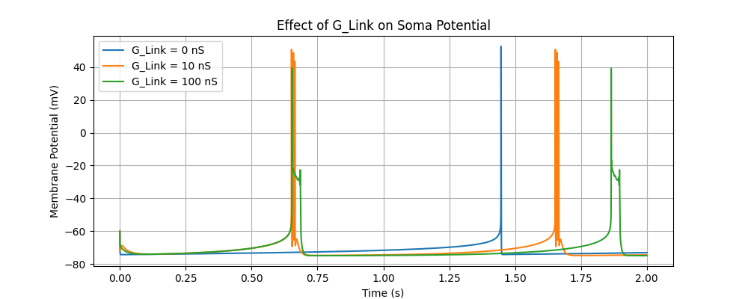

The bursts occur at different times for different G_Link values. Smaller G_Link (0 nS) results in bursts that occur later compared to larger G_Link (100 nS).

**Spike Characteristics:**

0 nS (blue): The soma bursts less frequently, and the spikes are sharper.

10 nS (orange): More frequent bursting, and bursts occur earlier compared to G_Link = 0 nS.

100 nS (green): Bursts are more frequent, and the soma potential fluctuates more before bursting.

**Amplitude of Soma Spikes:**

The peak spike amplitude is relatively similar across conditions. However, the transition from the resting state starts earlier as G_Link increases.

**Step 6: Injecting Current into Soma vs. Dendrite (line 228 - 263)**

Injected different currents (50 pA, 100 pA, and 200 pA) into either the soma or dendrite and compared their effects.

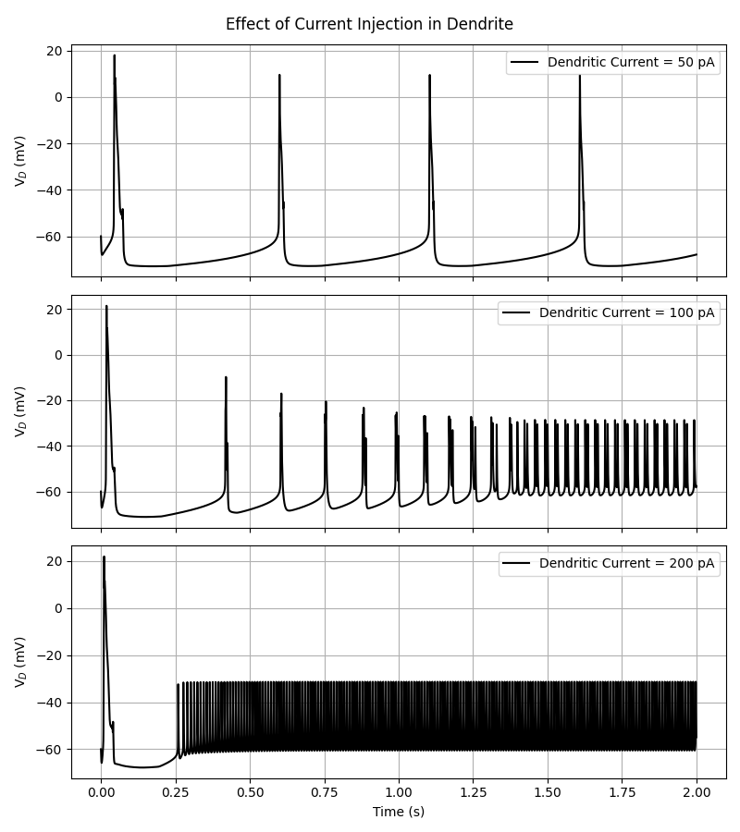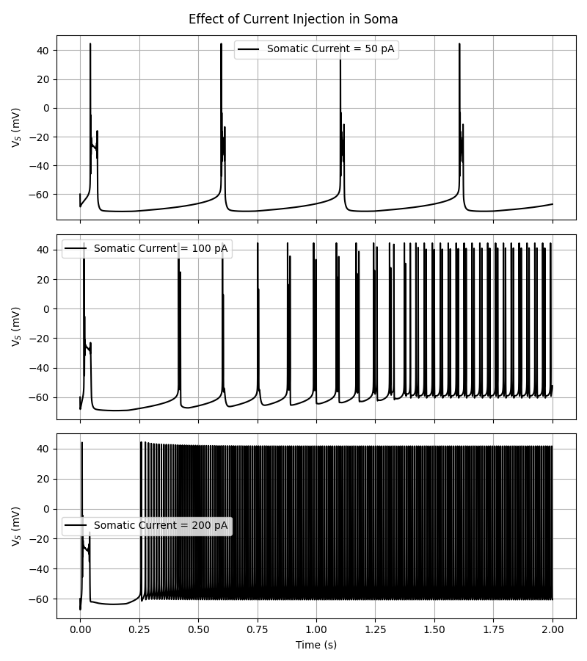

A common effect of increasing the injected current into both the soma and dendrite is an increase in firing frequency. At 200 pA, both compartments show sustained depolarization and high-frequency activity. In the soma, this occurs because the large depolarizing input prevents adequate hyperpolarization between spikes, leading to incomplete recovery from sodium channel inactivation. This can result in either continuous firing or a plateau potential where spikes stop entirely due to depolarization block. In the dendrite, high current disrupts the calcium- and potassium-mediated burst mechanisms, also resulting in tonic or irregular firing. Thus, while the outcome appears similar, the underlying dynamics differ between the soma and dendrite.

Soma injection leads to more regular and immediate responses, while dendrite injection modulates bursting patterns. At high currents, the neuron enters a tonic firing mode and has irregular oscillations in dendrite. In contrast, soma-driven firing is more stable than dendrite-driven firing.

Dendritic injection modulates burst shape and timing by engaging calcium and K⁺ conductances, which makes it less sensitive to current change and even when large current enters, the dendrite cannot depolarize as strongly or maintain a high potential. However, the soma is rich in voltage-gated sodium channels, which activate rapidly and drive large depolarizations. This aspect makes them behave differently under large applied current.